Practical - 5
Practical Title: Registration Form with Frontend Validation and User-Friendly Error Handling
Problem Definition: Create a student registration form with HTML5 input types and JavaScript validation for name, email, mobile number, password, confirm password, course, year, gender, and terms acceptance. Use Regular Expression for validations.
Theory:
- Are correct input types and attributes used?
Ans: Yes, semantic input types (text, email, tel, password, radio, checkbox) and appropriate attributes (id, placeholder, name, value) are correctly used for each field.

- Are validation errors displayed near the relevant fields?
Ans: Yes, each input field has a dedicated <span> element placed directly next to/beneath it (e.g., #name-error, #email-error, #password-error) where the error messages appear.

- Is password strength checked?
Ans: Yes, the regex pattern /^(?=.*[A-Za-z])(?=.*\d).{8,}$/ verifies that the password has a minimum length of 8 characters and contains at least one letter and one number.

- Is the form accessible using keyboard and screen-reader-friendly labels?
Ans: The form can be navigated using a keyboard via native inputs and buttons, but it lacks full screen-reader friendliness because the <label> tags are missing the for attribute to explicitly bind them to their input ids.

Implementation/ Output/Result :
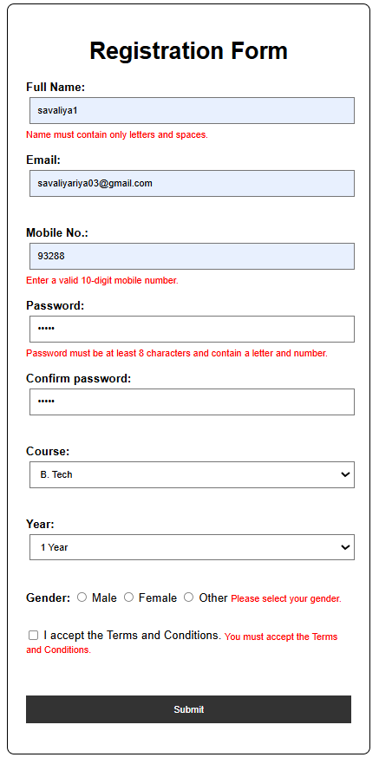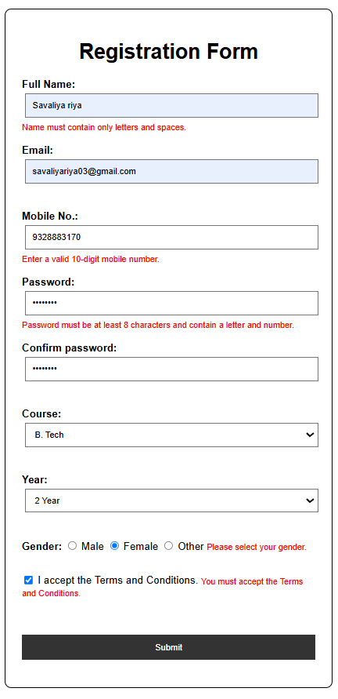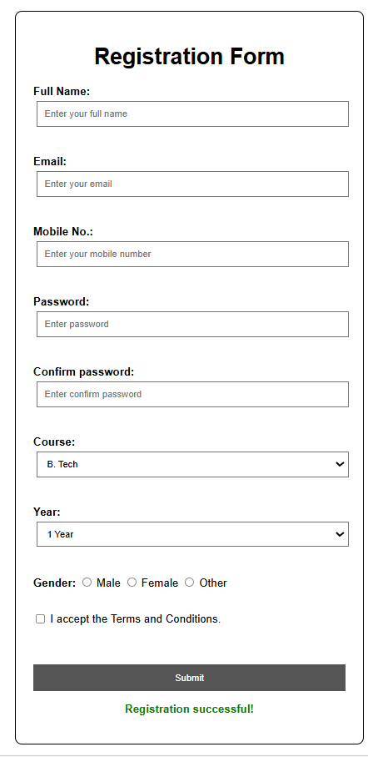

- GitHub Repository Link:
StudentHub/Regular-Expression at main · savaliyariya03/StudentHub
- Challenges Faced:
Writing complex Regular Expressions for password and email validation was tricky, as was clearing and updating individual error spans dynamically without refreshing the page.

- Learning Outcomes:
Learned how to validate and sanitize user inputs using JavaScript regex before form submission, and how to manipulate the DOM to show clear, inline error feedback.

- Faculty Remarks:

